**Topics: Descriptive Statistics and Probability**

1. Look at the data given below. Plot the data, find the outliers and find out $μ, σ, σ^{2}$

|  |  |
| --- | --- |
| **Name of company** | **Measure X** |
| Allied Signal | 24.23% |
| Bankers Trust | 25.53% |
| General Mills | 25.41% |
| ITT Industries | 24.14% |
| J.P.Morgan & Co. | 29.62% |
| Lehman Brothers | 28.25% |
| Marriott | 25.81% |
| MCI | 24.39% |
| Merrill Lynch | 40.26% |
| Microsoft | 32.95% |
| Morgan Stanley | 91.36% |
| Sun Microsystems | 25.99% |
| Travelers | 39.42% |
| US Airways | 26.71% |
| Warner-Lambert | 35.00% |

Ans.

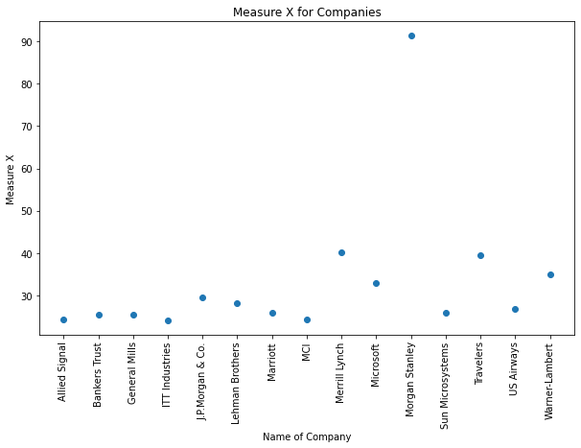

Morgan Stanley is an outlier with Measure X of 91.36%

Mean $(μ$) = 33.2713

Standard deviation $(σ)$ = 16.3708

Variance( $σ^{2})$ = 268.0035



Answer the following three questions based on the box-plot above.

1. What is inter-quartile range of this dataset? (please approximate the numbers) In one line, explain what this value implies.
2. What can we say about the skewness of this dataset?
3. If it was found that the data point with the value 25 is actually 2.5, how would the new box-plot be affected?

Ans. (i) Inter-quartile range [IQR]= 7, this range implies that mid 50% of the data lies under this range

(ii) The dataset is positively skewed

(iii) There would not be an outlier and the chances of the data to be symmetrically skewed would increase



Answer the following three questions based on the histogram above.

1. Where would the mode of this dataset lie?
2. Comment on the skewness of the dataset.
3. Suppose that the above histogram and the box-plot in question 2 are plotted for the same dataset. Explain how these graphs complement each other in providing information about any dataset.

Ans. (i) Mode of this dataset would lie where value of Y= 6

(ii) The dataset is positively skewed

(iii) Using both the Box-plot as well as the histogram it would be easier to verify the outlier skeweness, mode and the overall distribution of the data

1. AT&T was running commercials in 1990 aimed at luring back customers who had switched to one of the other long-distance phone service providers. One such commercial shows a businessman trying to reach Phoenix and mistakenly getting Fiji, where a half-naked native on a beach responds incomprehensibly in Polynesian. When asked about this advertisement, AT&T admitted that the portrayed incident did not actually take place but added that this was an enactment of something that “could happen.” Suppose that one in 200 long-distance telephone calls is misdirected. What is the probability that at least one in five attempted telephone calls reaches the wrong number? (Assume independence of attempts.)

Ans. Probability that at least one in five attempted telephone calls reaches the wrong number is 2.47%

1. Returns on a certain business venture, to the nearest $1,000, are known to follow the following probability distribution

|  |  |
| --- | --- |
| x | P(x) |
| -2,000 | 0.1 |
| -1,000 | 0.1 |
| 0 | 0.2 |
| 1000 | 0.2 |
| 2000 | 0.3 |
| 3000 | 0.1 |

1. What is the most likely monetary outcome of the business venture?
2. Is the venture likely to be successful? Explain
3. What is the long-term average earning of business ventures of this kind? Explain
4. What is the good measure of the risk involved in a venture of this kind? Compute this measure

Ans. (i) The most likely monetary outcome of the business venture is $2,000.

(ii) When we compare the negative return to the positive return, the positive return is more, hence the chances of success are more

(iii) Long term average is $800

[(-2,000*0.1)+(-1,000*0.1)+(0*0.2)+(1000*0.2)+(2000*0.3)+(3000*0.1)]= $800

1. A good measure of risk involved is standard deviation , here the standard deviation is $1469.693